AUTO TICKET CLASSIFICATION USING FLOW DESIGNER

Documentation phase

School IT Helpdesk — ServiceNow Implementation Report

Overview of Project

This project delivers a no-code ServiceNow automation that classifies School IT Helpdesk tickets automatically the moment they are logged, removing the need for manual triage by IT staff. A custom Incident WorkFlow table captures each ticket, and a Flow Designer flow reads the Short Description, assigns the correct Category and Subcategory, and emails the caller a confirmation — end to end, with no scripting.

Problem Statement
The school IT helpdesk receives multiple incident requests daily from students and teachers, such as Wi-Fi issues, projector failures, password problems, and slow computers. Currently, IT staff manually reviews each request and assigns a category, which is time-consuming and inefficient.
This project automates ticket classification using ServiceNow Flow Designer by analyzing keywords in the incident's Short Description field, so that every ticket is categorized the moment it is created — with no manual triage required.

Objective
- Automatically classify incidents at the time of creation.
- Reduce manual effort for IT agents.
- Improve ticket routing efficiency.
- Implement a no-code, easily maintainable solution using Flow Designer.
- Notify the caller automatically once the ticket is logged.

Skills Required
- ServiceNow platform administration — navigating All menus, System Definition, and System Update Sets.
- Custom table and field configuration — creating tables, setting data types, auto-numbering, and Access Controls.
- Dictionary configuration — setting up dependent Choice fields between Category and Subcategory.
- Flow Designer — building triggers, If / Else If conditions, Update Record actions, and Send Email actions.
- Update Set management — tracking, completing, and exporting customizations for deployment.
- Testing and validation — verifying end-to-end automation logic and confirming email notifications.

Milestone 1: Requirement Analysis & Planning
The school IT helpdesk receives multiple support requests daily from students and teachers related to common issues such as network connectivity, hardware failures, account access problems, and system performance issues. Currently, IT staff manually review each ticket to identify the issue type, select the correct category and subcategory, and inform the caller about ticket creation. This manual process is time-consuming, error-prone, and not scalable as the number of requests increases.

Activity 1: Business Use Case

Business Requirements
The system must:
- Automatically classify IT tickets based on the issue description.
- Assign both Category and Subcategory without manual intervention.
- Support dependent choice logic between Category and Subcategory.
- Send an automated email notification to the caller upon ticket creation.
- Store ticket information in a structured and standardized format.
- Ensure easy maintenance and future scalability.

Activity 2: Creation of New Update Set
All customizations for this project are tracked inside a dedicated Update Set so that they can be exported and moved between instances cleanly.

Navigation Steps
- Go to All menus → search for Local Update Sets.
- Under System Update Sets → select Local Update Sets.
- Name: Project Update Set
- State: In progress
- Application: Global
- Save the form, then under Related Links click Make This My Current Set.
- The created Update Set now appears as the current/active update set in the top banner.
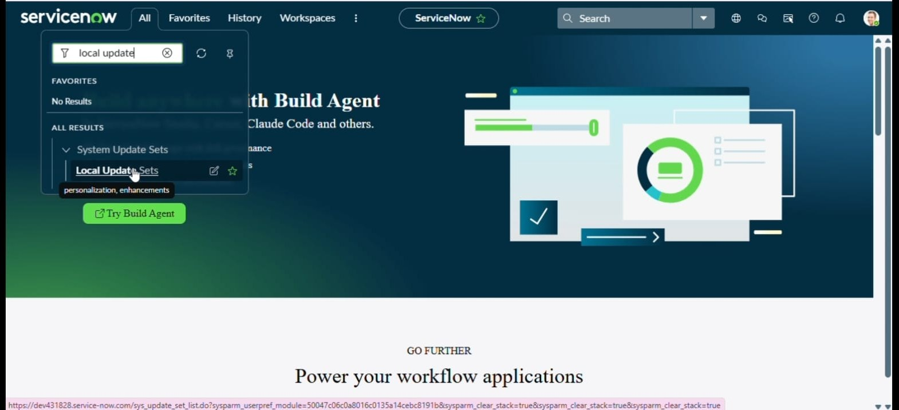
Locating Local Update Sets from the All menu
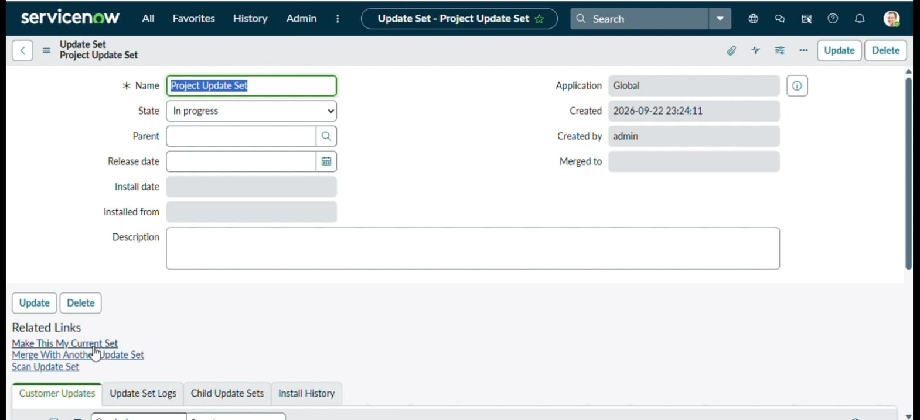
Project Update Set record, State: In Progress, Application: Global
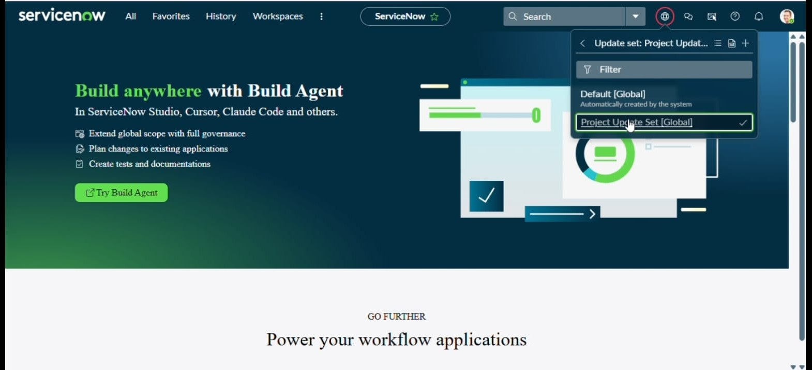
Project Update Set marked as the current active update set

Milestone 2: Backend Development & Configuration

Activity 1: Creation of Custom Table to Store Ticket Records

Steps to Create the Custom Table
- Open All menus → search for Tables.
- Under System Definition → click Tables → click New.
- Label: Incident WorkFlow
- Name (auto-generated): u_incident_workflow
- Uncheck Create module (no separate application-menu module is needed for this build).
- Save the form, then open the Controls tab and enable Auto-number.
- Prefix: INC
- Number: 1000
- Number of digits: 7
- Save again. ServiceNow auto-creates four default Access Controls (create, read, write, delete) on the new table.
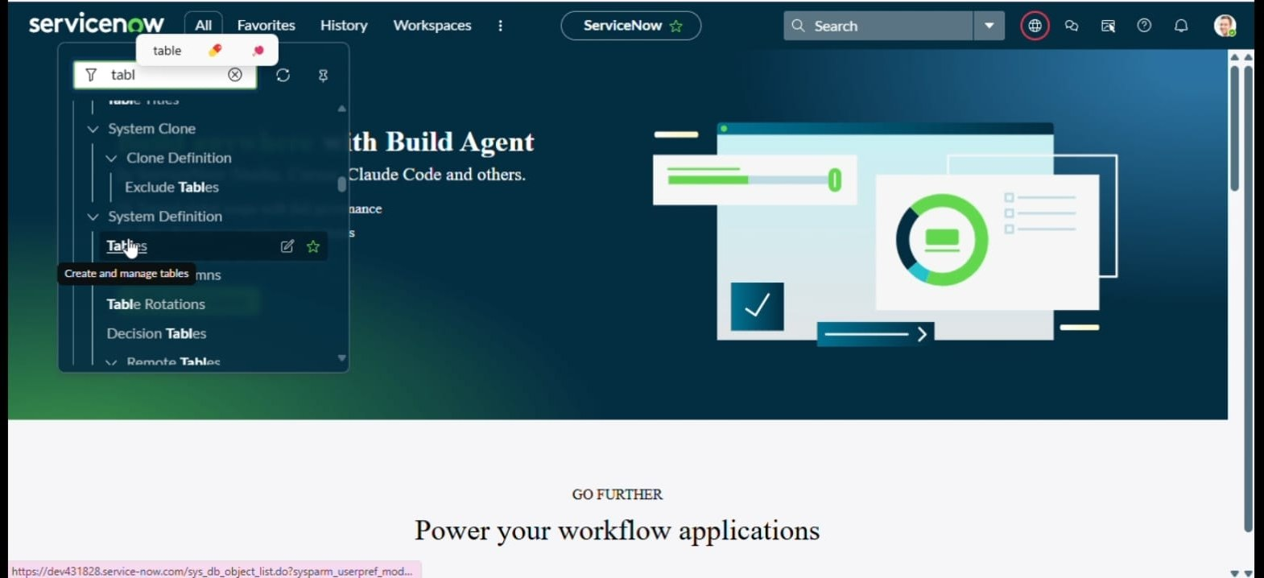
Searching for Tables under System Definition
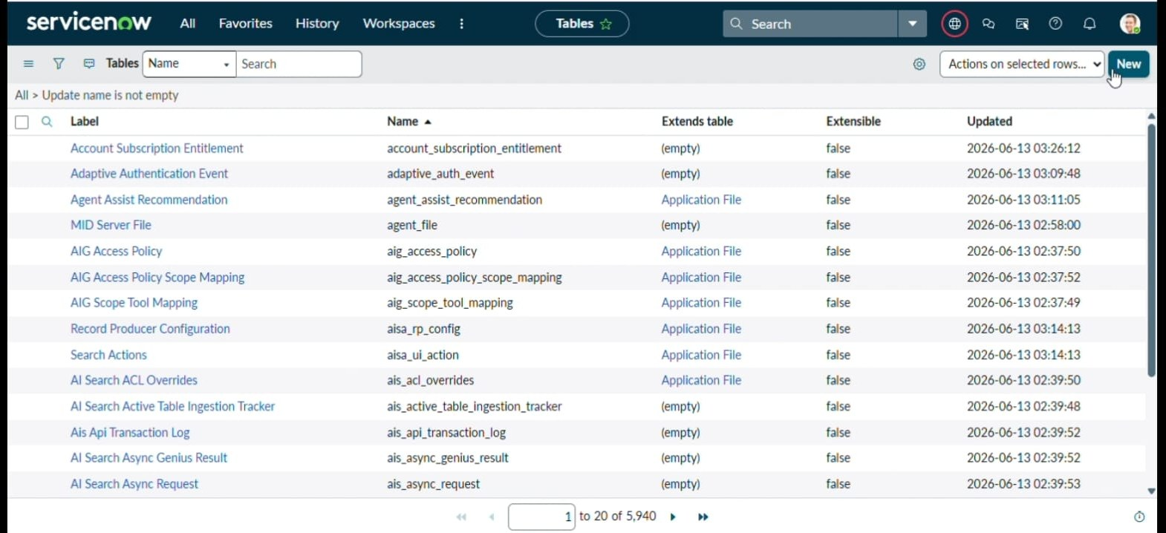
Tables list with the New button
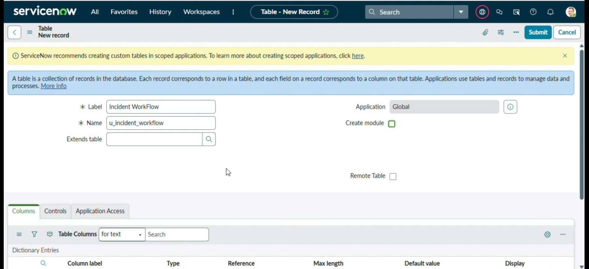
New Table record: Label = Incident WorkFlow, Name = u_incident_workflow, Application = Global
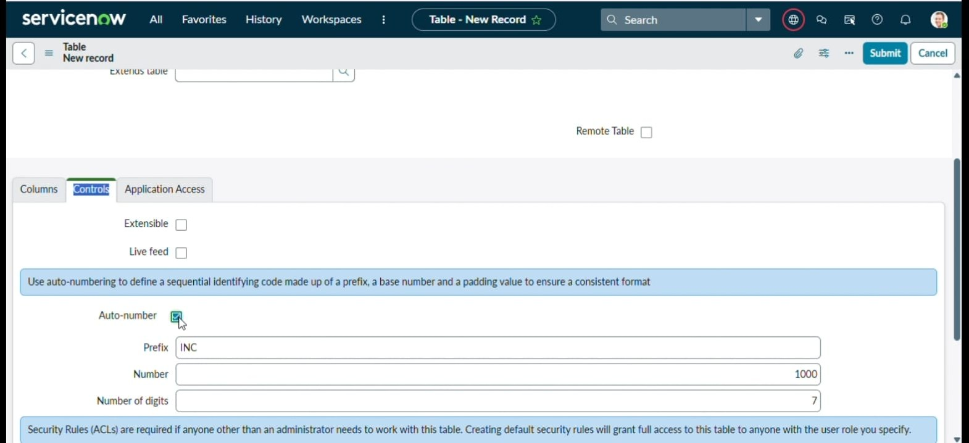
Controls tab: Auto-number enabled with Prefix INC, Number 1000, 7 digits
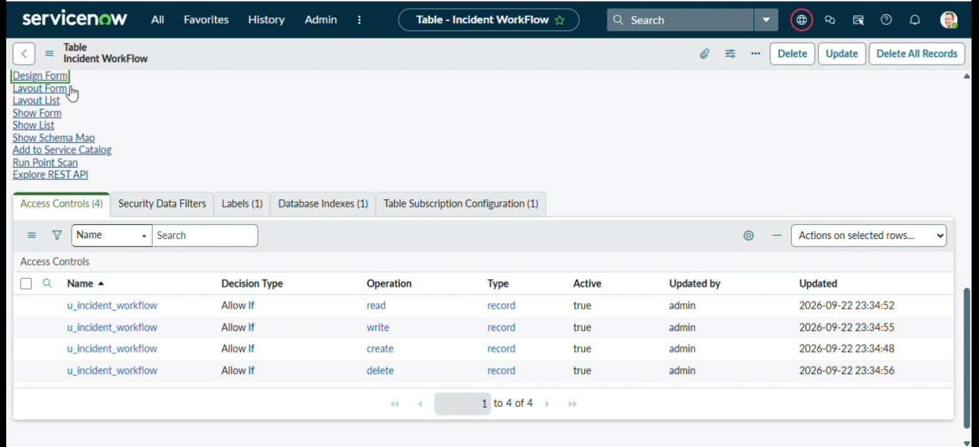
Incident WorkFlow table with default Access Controls (create/read/write/delete)
Under Related Links, Show Form opens the actual record form, and the context‑menu Configure → Form Design opens Form Designer where the required fields are added.

Activity 2: Field Creation and Data Type Configuration
The objective of this activity is to create all required fields on the Incident WorkFlow table with the correct data types, choices, and dependencies, so that ticket data is captured in a structured and consistent format.
Field Label | Type | Reference / Choice
Number | Auto Number | INC — 7 digits, starting 1000
Caller | Reference | sys_user
Category | Choice | Network, Hardware, Access, Performance
Subcategory | Choice | Wi-Fi, Projector, Forgot Password, Slow Computer
Short Description | String | —
Description | String | —
State | Choice | New, In Progress, On Hold, Resolved, Closed
Assigned Group | Reference | sys_user_group
Assigned to | Reference | sys_user

After creating the fields with their appropriate types, the choice values were added directly from Form Design for every Choice-type field (Category, Subcategory and State).
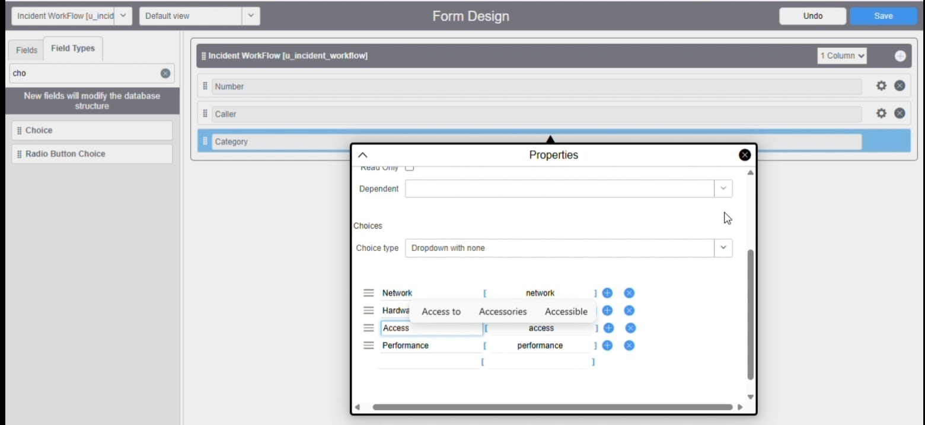
Category field choices: Network, Hardware, Access, Performance
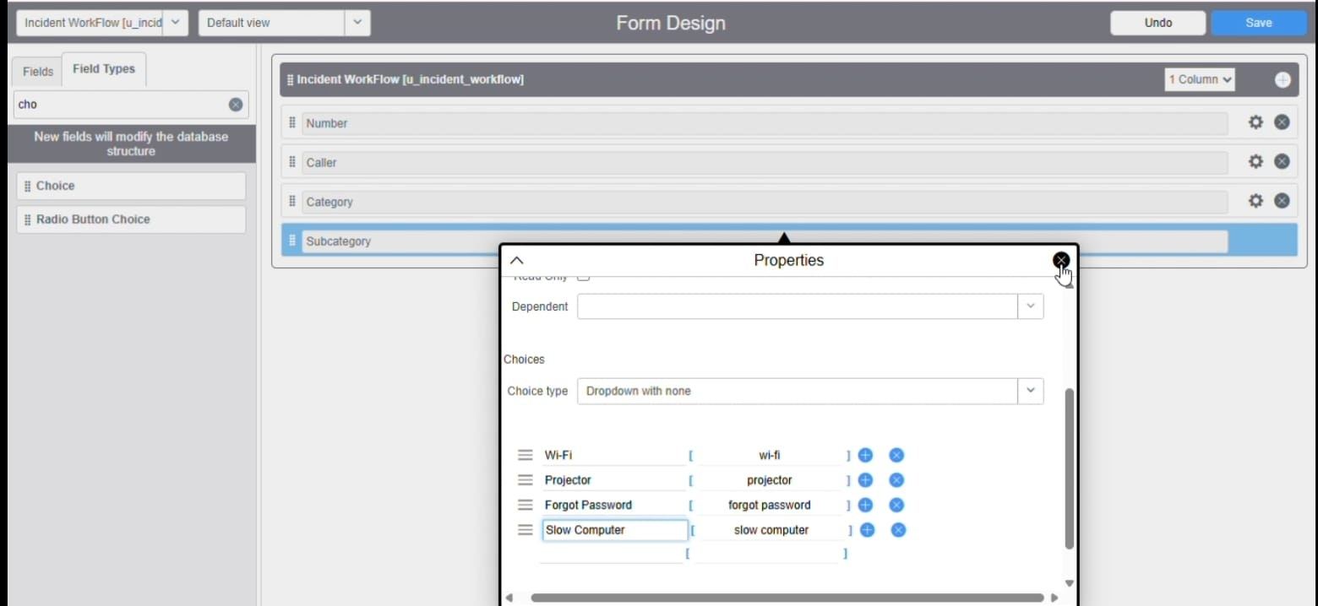
Subcategory field choices: Wi-Fi, Projector, Forgot Password, Slow Computer
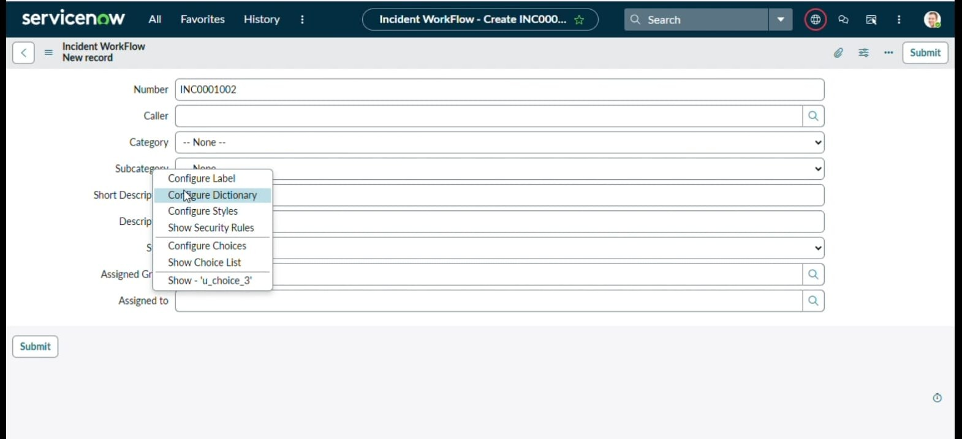
Completed Incident WorkFlow form showing all created fields

Activity 3: Implementing Dependency Between Category and Subcategory Choice Fields
The objective of this activity is to implement a dependency relationship between the Category and Subcategory fields, so that the available Subcategory options dynamically change based on the selected Category.

Navigation Steps
- Right-click the Subcategory field on the form → Configure Dictionary.
- Under Related Links, open Advanced view, then go to the Dependent Field tab.
- Enable the checkbox Use dependent field.
- Dependent on field: Category
- Save the form.
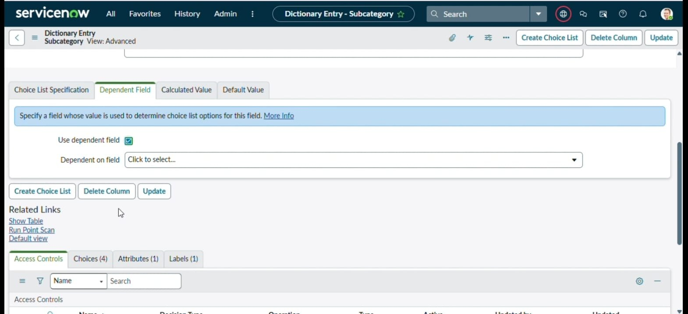
Dictionary Entry for Subcategory, Advanced view, Dependent Field tab
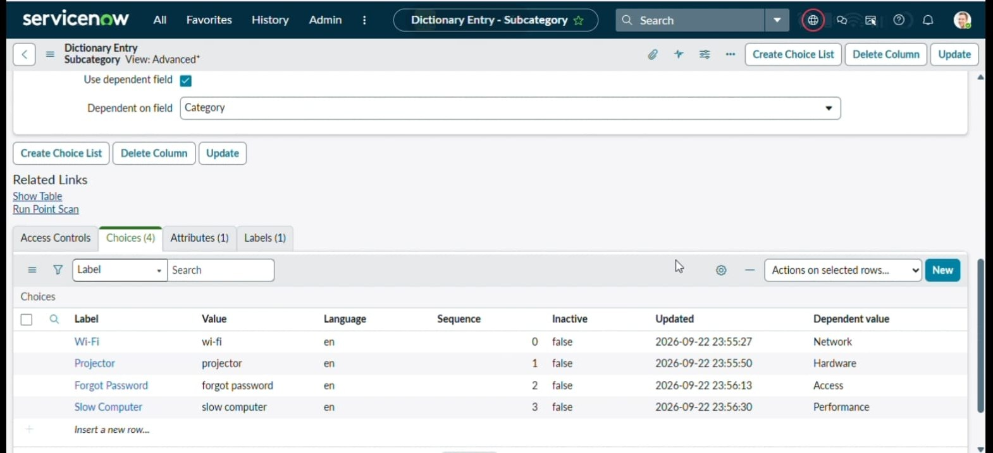
Use dependent field enabled, Dependent on field = Category
Next, each Subcategory choice was mapped to the backend value of its parent Category, under the Choices related list:
Subcategory Choice | Dependent Value (Category)
Wi-Fi | Network
Projector | Hardware
Forgot Password | Access
Slow Computer | Performance

Once saved, the Subcategory dropdown on the form now dynamically filters to show only the values that belong to the selected Category. This was verified for all four combinations:
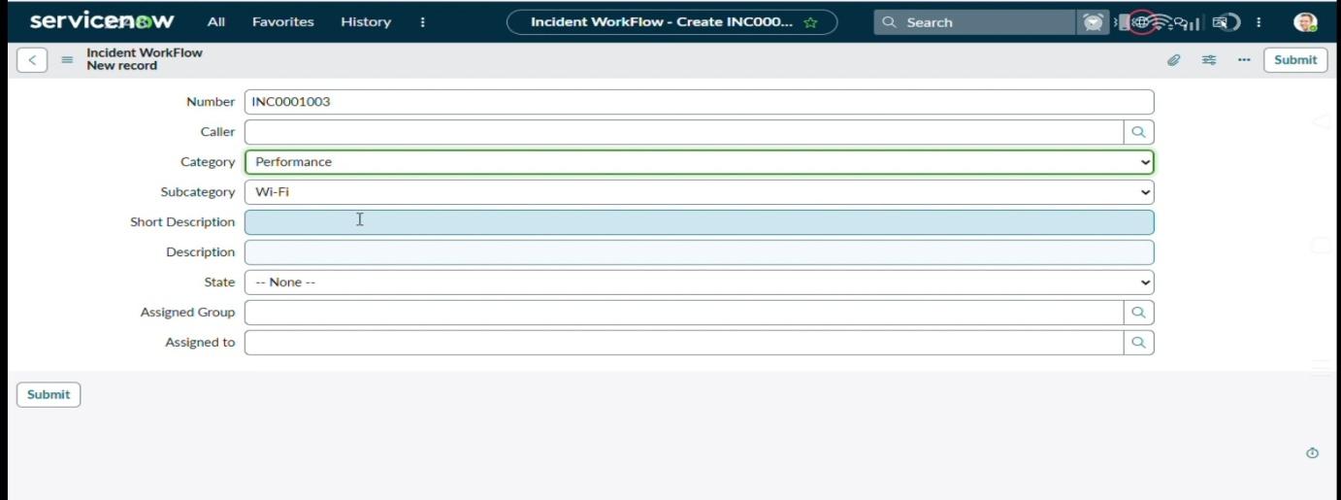
Category = Performance, Subcategory list filtered accordingly
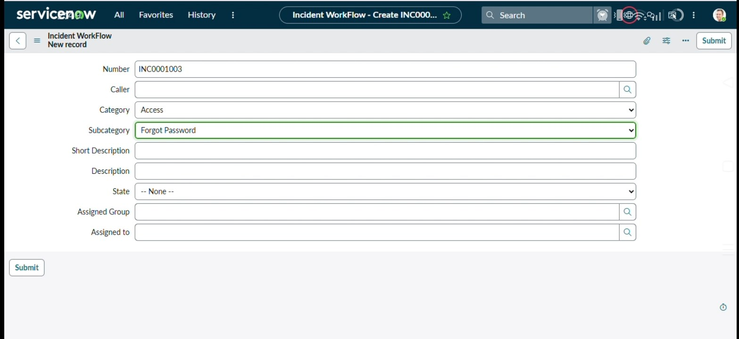
Category = Access → Subcategory correctly shows Forgot Password
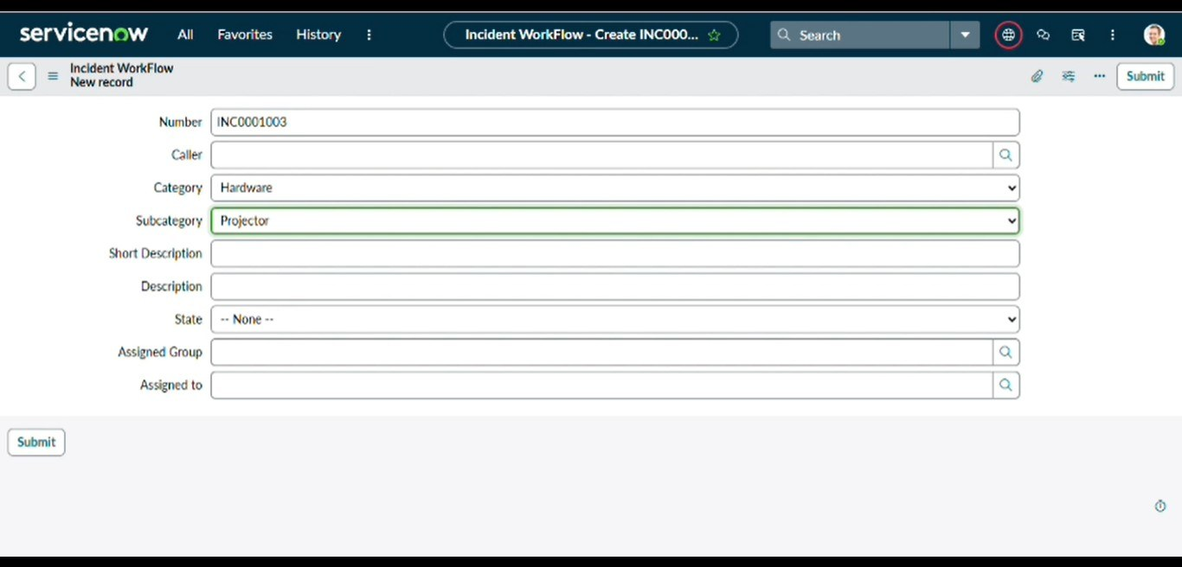
Category = Hardware → Subcategory correctly shows Projector
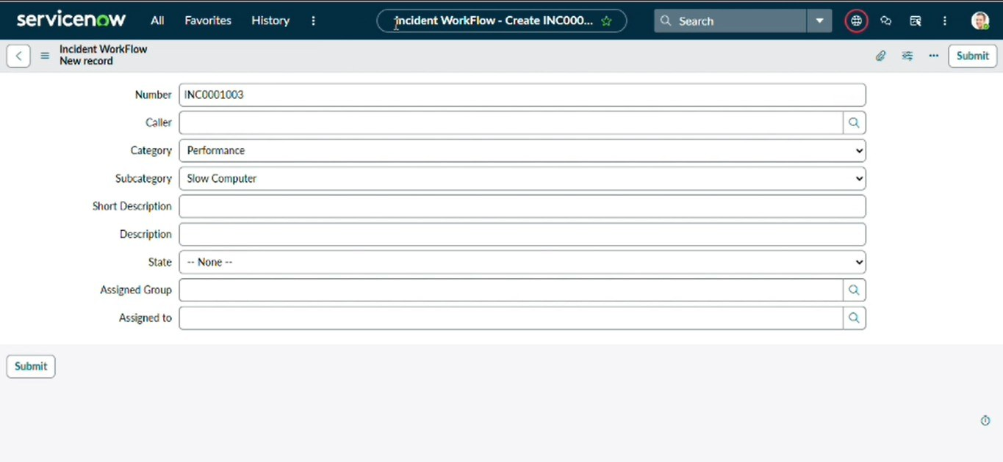
Category = Performance → Subcategory correctly shows Slow Computer

Milestone 3: Automation using Flow Designer & Email Notification
When a student or teacher creates a new IT support ticket, they only need to enter the Caller and the Short Description of the issue — they do not need to manually select the Category or Subcategory. Once the ticket is submitted, a Flow Designer automation is triggered and evaluates the Short Description for predefined keywords such as Wi-Fi/Network, Projector, Forgot Password, or Slow Computer. Based on the identified keyword, the flow automatically assigns the appropriate Category and Subcategory to the ticket, then emails the caller a confirmation.
- If the Short Description contains Wi-Fi or Network → Category = Network, Subcategory = Wi-Fi.
- If the Short Description contains Projector → Category = Hardware, Subcategory = Projector.
- If the Short Description contains Forgot Password → Category = Access, Subcategory = Forgot Password.
- If the Short Description contains Slow computer → Category = Performance, Subcategory = Slow Computer.
This automation ensures consistent classification, eliminates human error, and significantly reduces the manual effort required by IT staff. The entire process is implemented using Flow Designer, making the solution easy to maintain, scalable, and completely no-code.

Activity 1: Auto Classification using Flow Designer
- Go to All menus → search Flow Designer, under Process Automation.
- On the top right, click New → Flow.
- Flow name: Auto Classify School IT Tickets
- Application: Global
- Click Build Flow to open Workflow Studio.

Activity 2: Trigger Configuration
- Trigger: Record Created
- Table: Incident WorkFlow
- Condition: Category is empty
- This ensures the flow only fires for brand-new tickets where the category has not already been set.

Activity 3: Wi-Fi / Network Issue Classification
- Add an If action.
- Condition label: SD is Wifi or Network
- Condition 1: Short description contains "Wi-Fi", OR
- Condition 2: Short description contains "Network".
- Then action → Update Record on the Incident WorkFlow table:
- Category = Network
- Subcategory = Wi-Fi
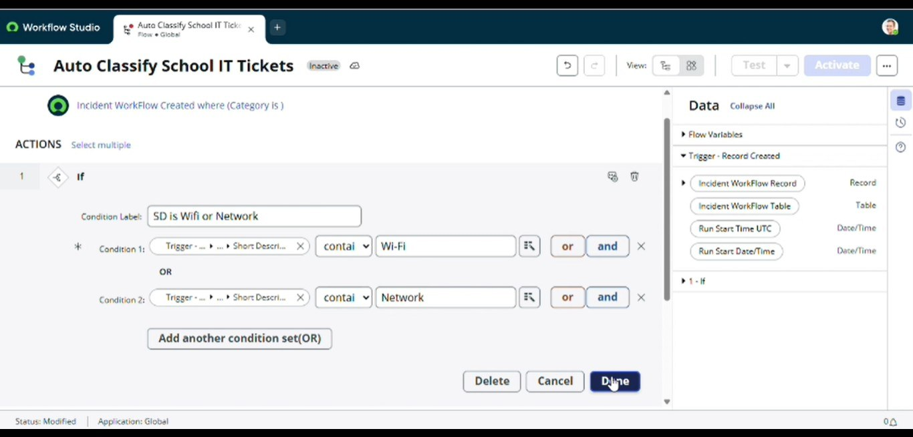
If condition: Short Description contains Wi-Fi OR Network
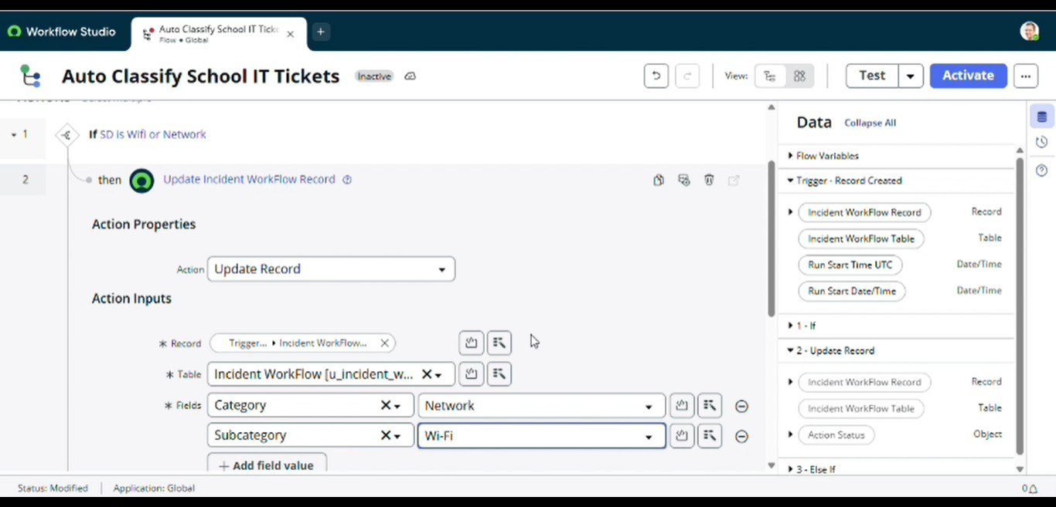
Update Record action setting Category = Network, Subcategory = Wi-Fi

Activity 4: Projector Issue Classification
- Add an Else If action.
- Condition label: SD is Projector or Hardware
- Condition: Short description contains "Projector".
- Category = Hardware
- Subcategory = Projector
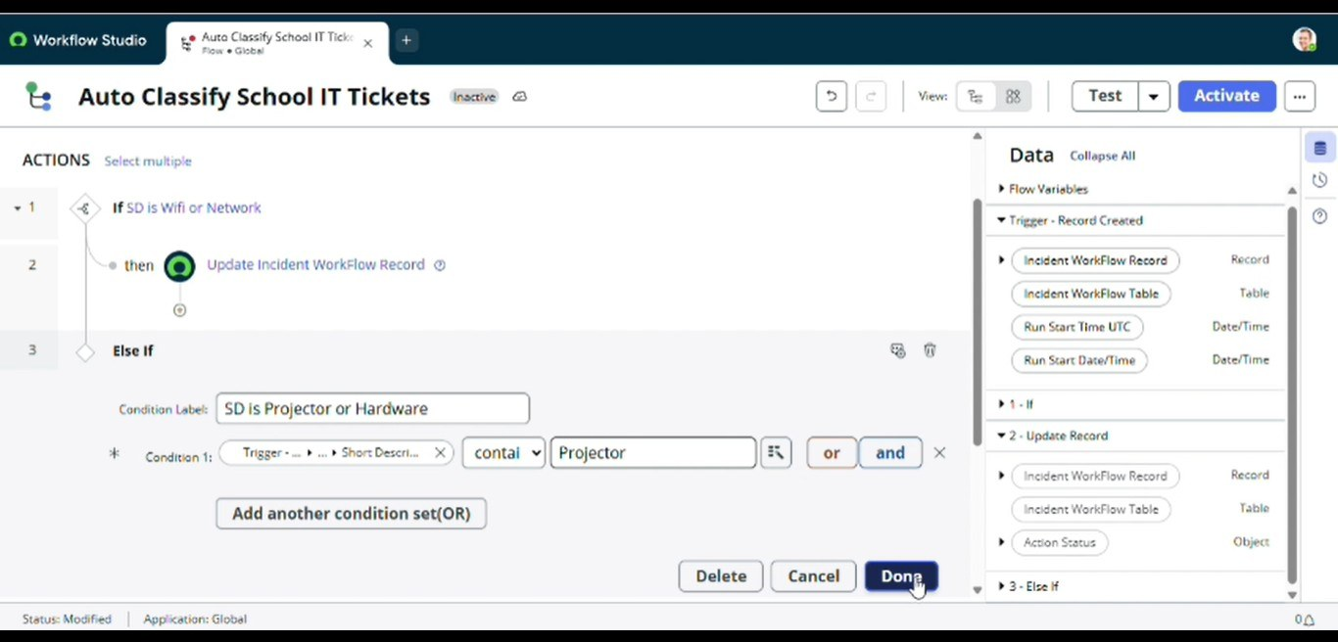
Else If condition: Short Description contains Projector
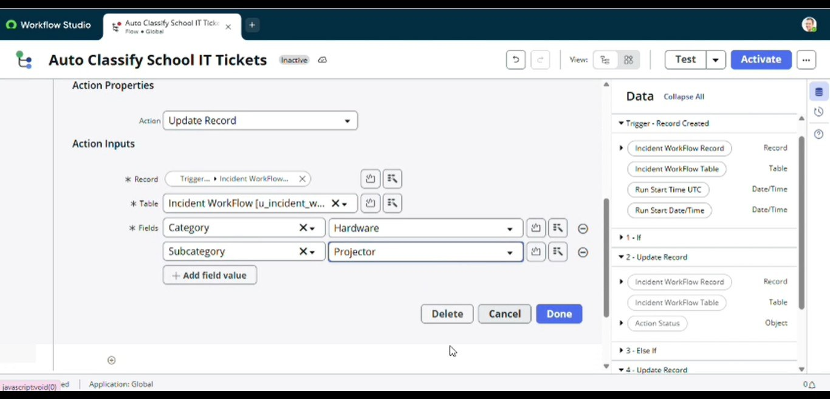
Update Record action setting Category = Hardware, Subcategory = Projector

Activity 5: Password Issue Classification
- Add another Else If action.
- Condition label: SD is Forgot Password
- Condition: Short description contains "Forgot Password".
- Category = Access
- Subcategory = Forgot Password
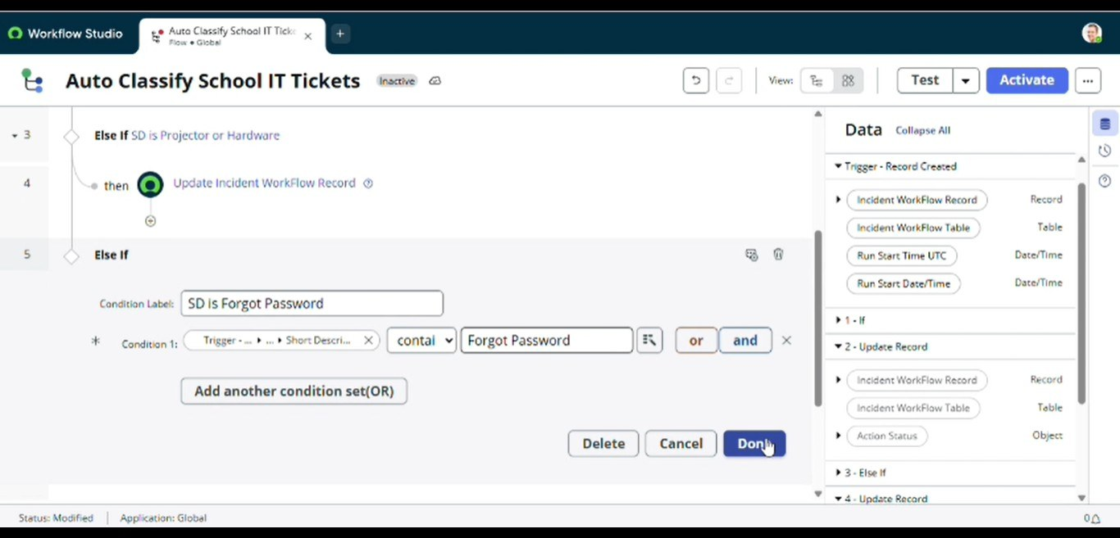
Else If condition: Short Description contains Forgot Password
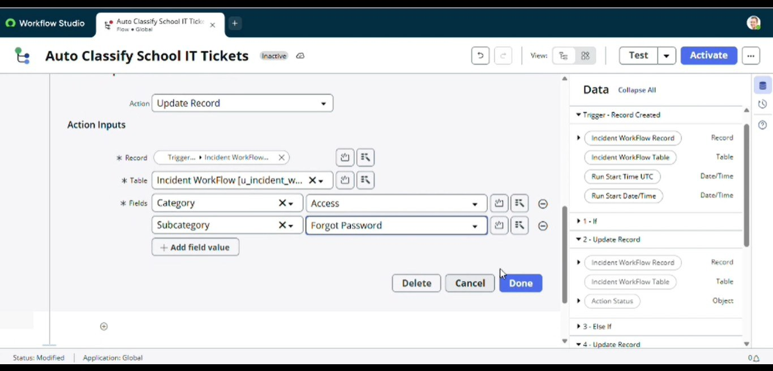
Update Record action setting Category = Access, Subcategory = Forgot Password

Activity 6: Slow Computer Classification
- Add the final Else If action.
- Condition label: SD is Performance
- Condition: Short description contains "Slow computer".
- Category = Performance
- Subcategory = Slow Computer
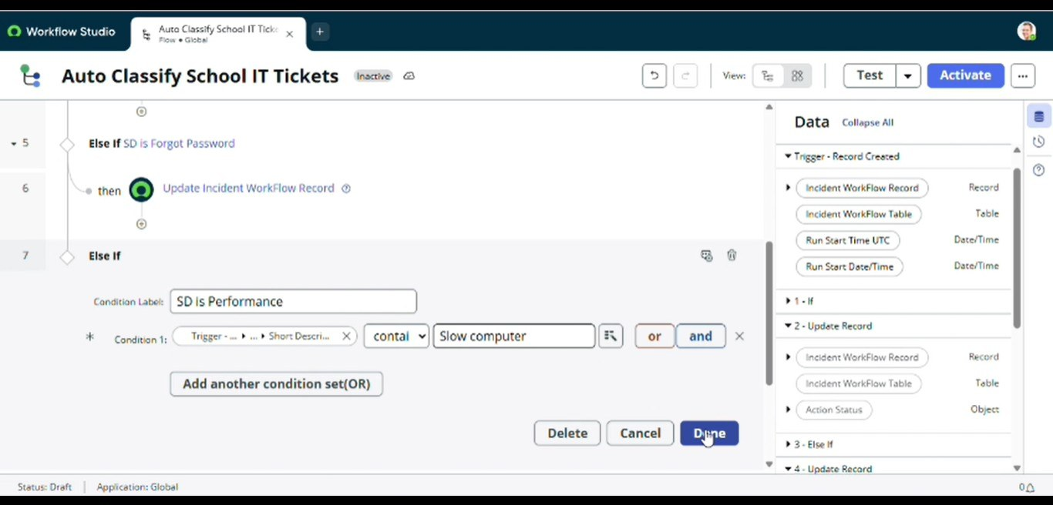
Else If condition: Short Description contains Slow computer
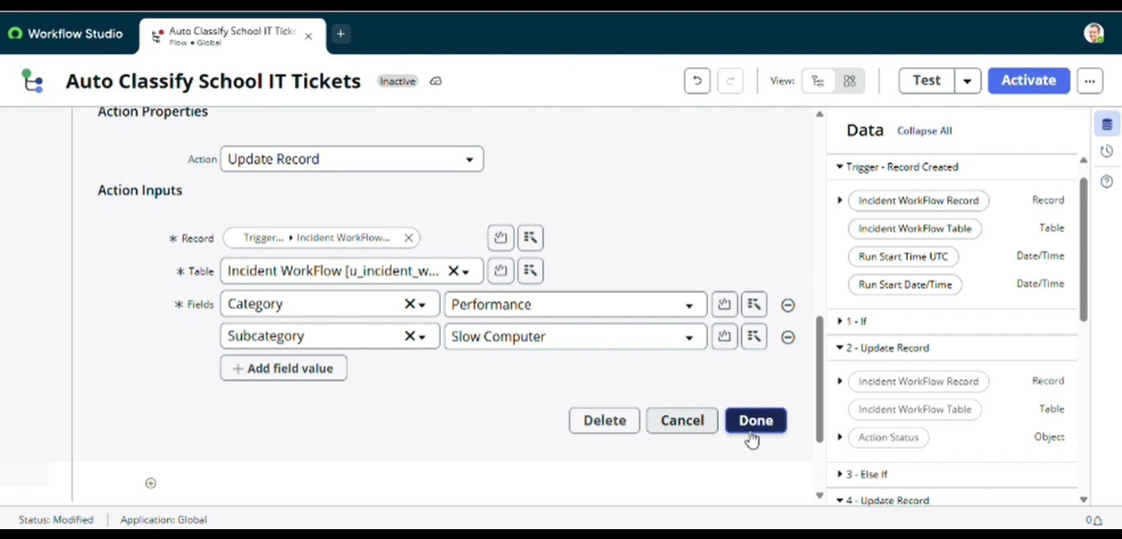
Update Record action setting Category = Performance, Subcategory = Slow Computer

Activity 7: Email Action Setup
After classification, an email notification is sent to the caller using a Send Email action added as the final step of the flow.
- Action: Send Email
- Target Record / Table: Incident WorkFlow
- To: Caller → Email (via data pill picker)
- Subject: "Your Request for the issue has been submitted."
- Body: Ticket confirmation message to the caller.
- Once every branch and the email step were wired up, the flow was Activated (moved from Draft/Inactive to Published/Active) from the top-right corner.
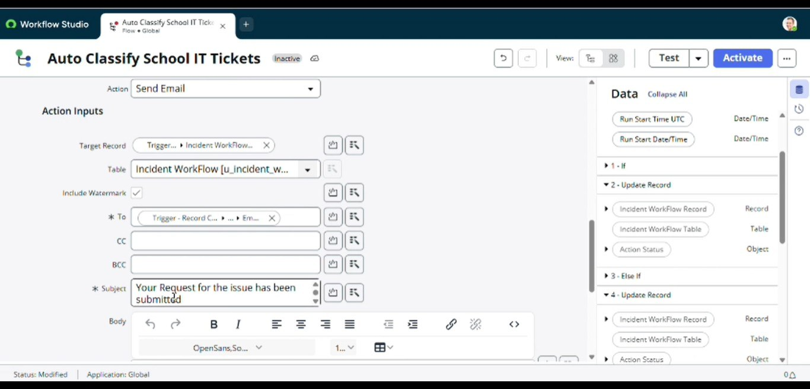
Send Email action inputs: Table, To (Caller's Email), Subject
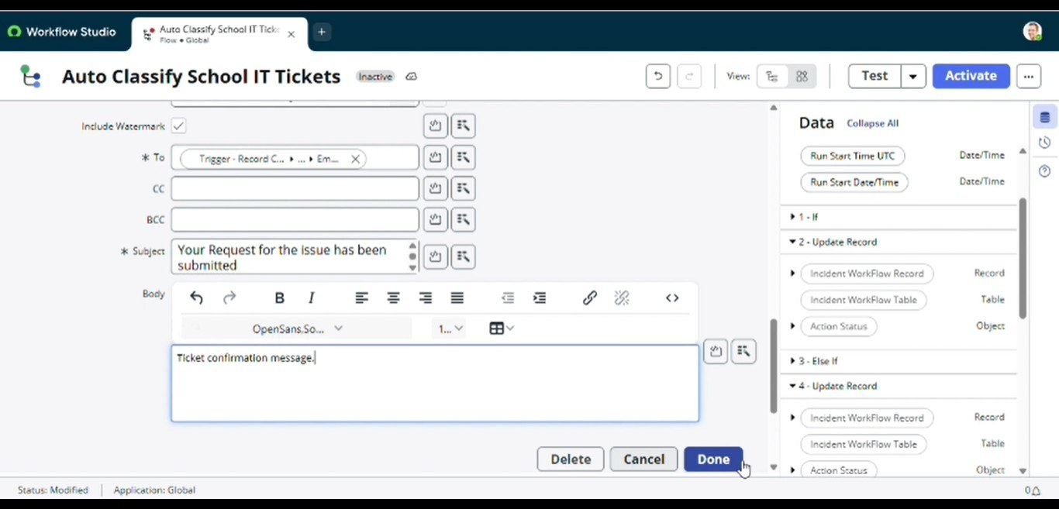
Email body: ticket confirmation message
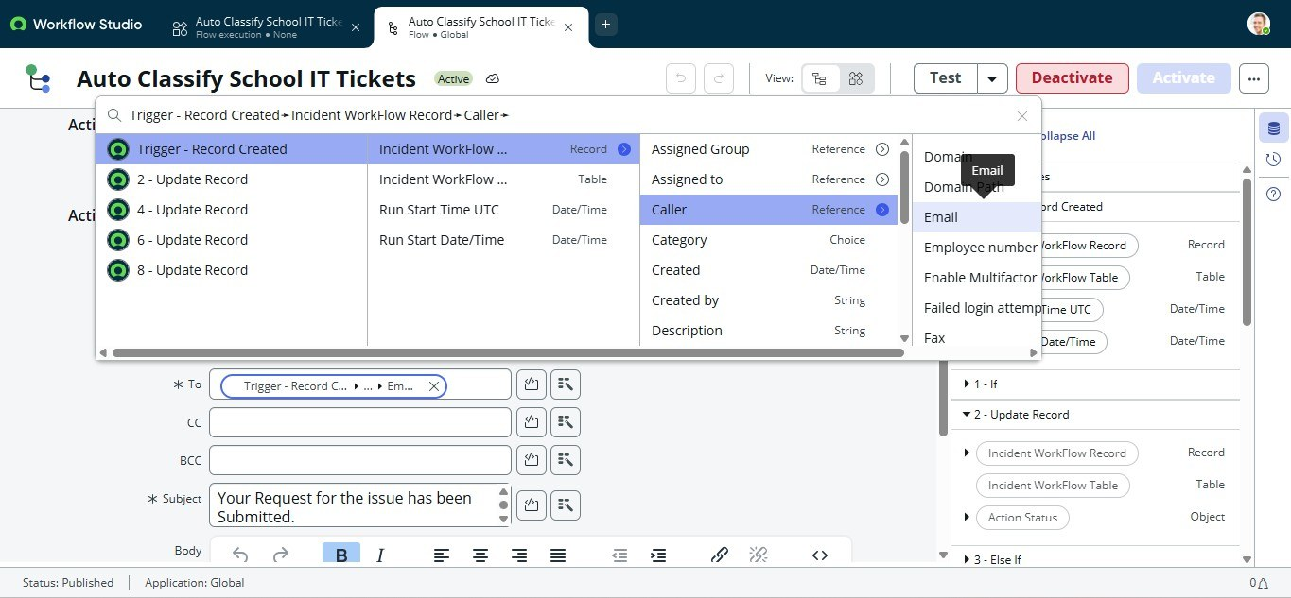
Data pill picker used to map Caller → Email; flow shown Active/Published

Milestone 4: Testing, Validation & Security
The objective of this phase is to ensure that the developed solution works as expected, meets all functional requirements, and follows basic security and access control best practices. This phase validates the end-to-end automation, confirms data accuracy, and ensures that only authorized users can access or modify ticket data.

Data Validation Checks
- Mandatory fields captured correctly.
- Auto-number generated without duplication (INC0001000 series, 7-digit padding).
- Category and Subcategory values stored accurately, driven purely by the flow logic.
- Reference fields (Caller, Assigned Group, Assigned to) resolve correctly to the user and group tables.

Activity 1: Testing & Validation

Test Scenario — Network / Wi-Fi Keyword
- Caller: Alfonso Griglen
- Short Description: "My College Has issue with Network"
- Ticket saved and reloaded.
Result — the flow fired automatically and filled in:
- Ticket Number: INC0001024
- Category → Network
- Subcategory → Wi-Fi
- A confirmation email was sent automatically to the caller's registered email address.
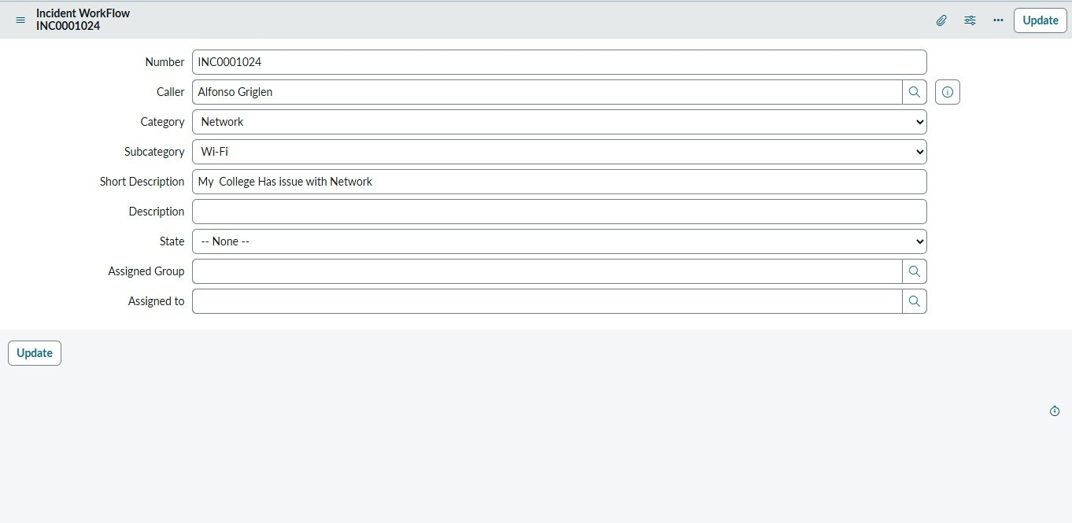
INC0001024 auto-classified as Category: Network, Subcategory: Wi-Fi

Activity 2: Check Email Notification
- Open All menus → search Emails, under System Logs.
- Search using the notification subject.
- Open the record and, under Related Links, click Preview Email.
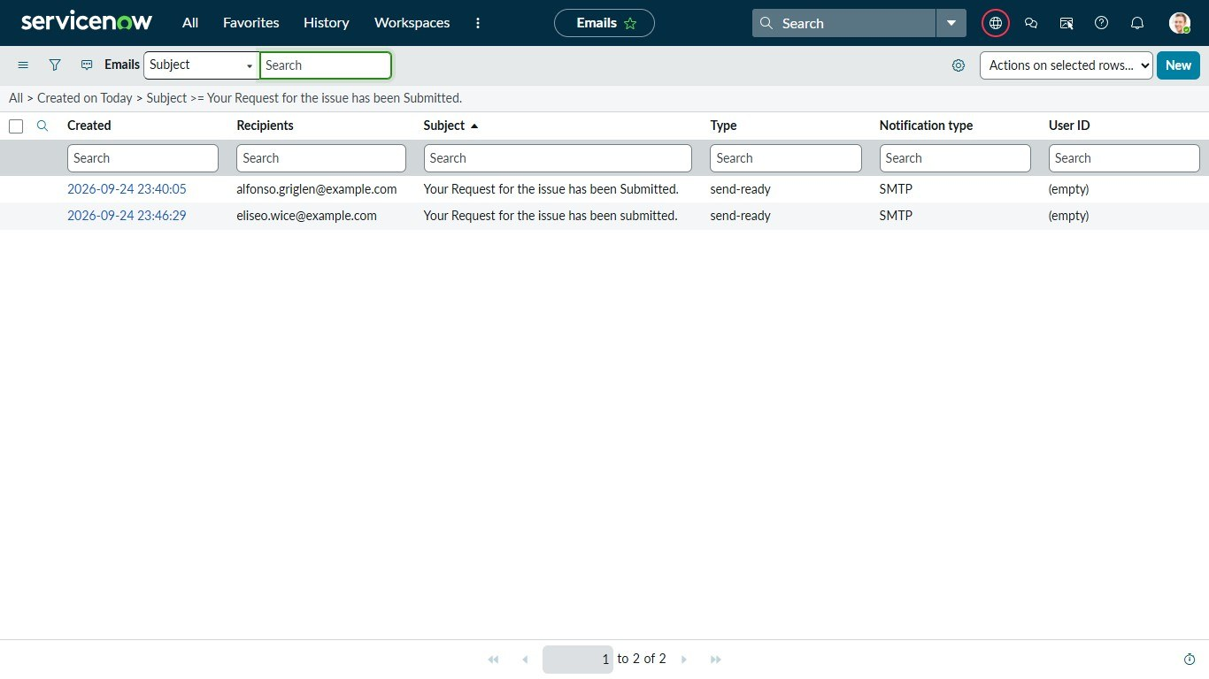
Email log showing two outbound notifications with subject "Your Request for the issue has been Submitted."
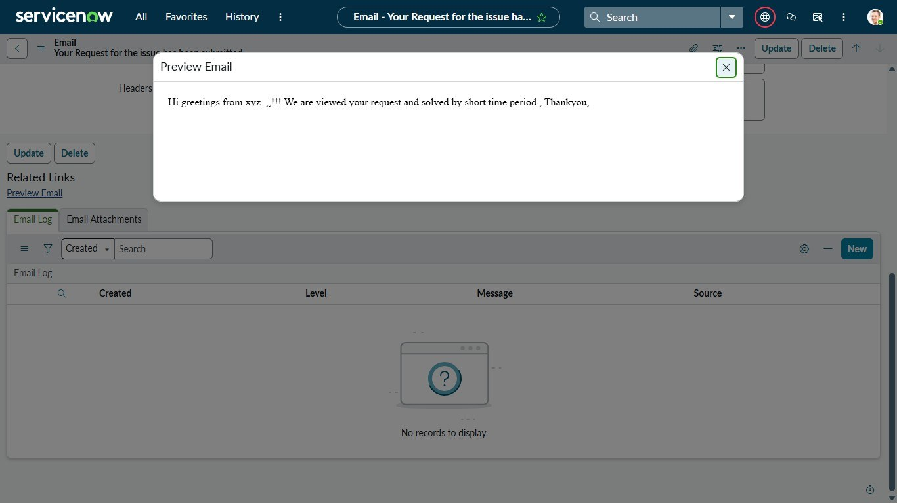
Email preview: automated confirmation message sent to the caller
The email log confirms delivery to the caller's address, and the previewed content matches the confirmation message configured in the flow's Send Email step — validating that the end-to-end automation (classification + notification) works correctly.

Milestone 5: Deployment & Conclusion
The objective of this phase is to deploy the developed solution to the target environment and finalize all project documentation. This phase ensures that the solution is stable, reusable, and ready for demonstration or production use, along with complete and clear documentation for future reference.

Activity 1: Make Update Set to Complete State
- Go to All menus → search Local Update Sets.
- Under System Update Sets → select Local Update Sets.
- Open the Project Update Set.
- State: changed from In Progress to Complete
- Save the form. The Customer Updates related list now shows all 40 captured customizations (table, columns, dictionary entries, choice lists, the flow, and its actions).
- Under Related Links, click Export to XML.
- The Update Set is downloaded to the local system as an XML file, ready to be imported into another ServiceNow instance (or shared via email/collaboration tools) for deployment.
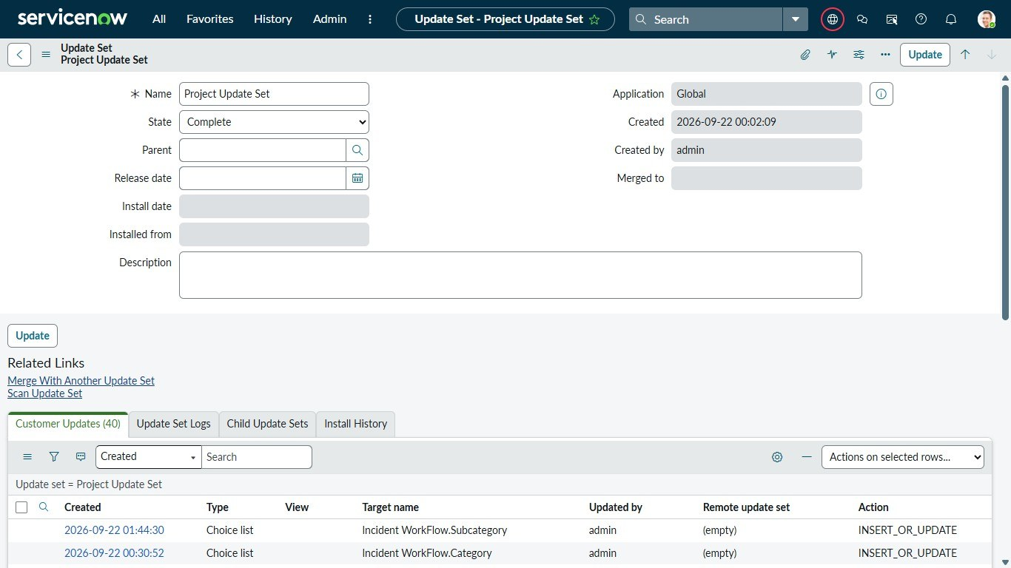
Project Update Set marked Complete, with 40 captured Customer Updates
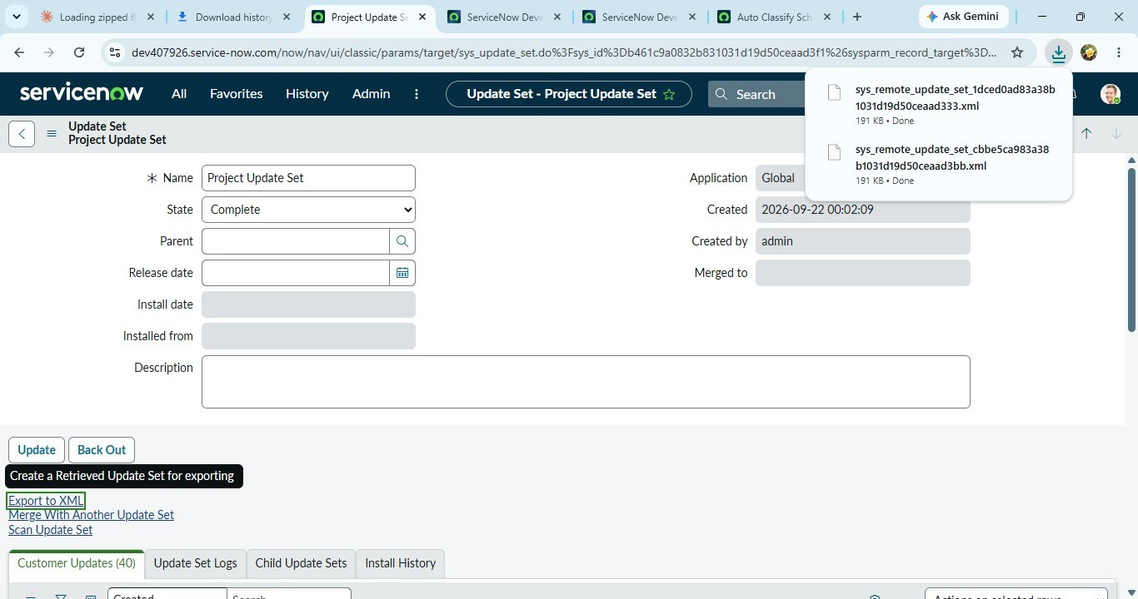
Update Set exported to XML and downloaded to the local system

Conclusion
The Auto Ticket Classification using Flow Designer project successfully delivers a complete, end-to-end automation solution for a school IT helpdesk. The primary objective of reducing manual effort in ticket categorization and improving response efficiency has been fully achieved.
Through structured requirement analysis, careful backend configuration on the custom Incident WorkFlow table, and no-code automation using Flow Designer, the system now automatically classifies IT tickets based on the Short Description provided by the caller. The dependent Category–Subcategory choice fields ensure data accuracy during manual entry, while the automated email notification improves communication by instantly acknowledging ticket creation to the caller.
The solution was developed using a phased approach — requirement analysis, backend configuration, automation, testing, and deployment — ensuring clarity, stability, and ease of maintenance. Testing with a live ticket (INC0001024) confirmed that the flow correctly classifies tickets and triggers the email notification, and the Update Set export confirms the solution is ready for deployment to other instances.
Overall, this project demonstrates how ServiceNow can be effectively used to build scalable, maintainable, and user-friendly automation solutions without relying on complex scripting or machine learning. The design is well-suited for small to medium environments such as educational institutions and can be easily extended in the future to include advanced features like assignment automation, SLA tracking, or predictive intelligence.

